EC2 instance connected with terminal:
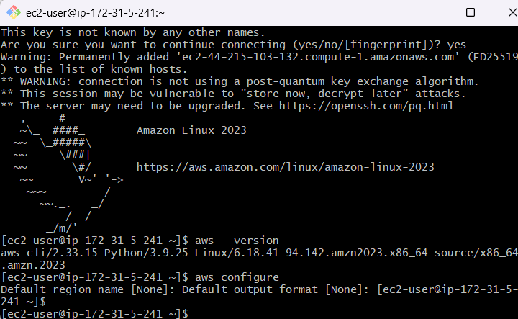

AWS CLI Configured:
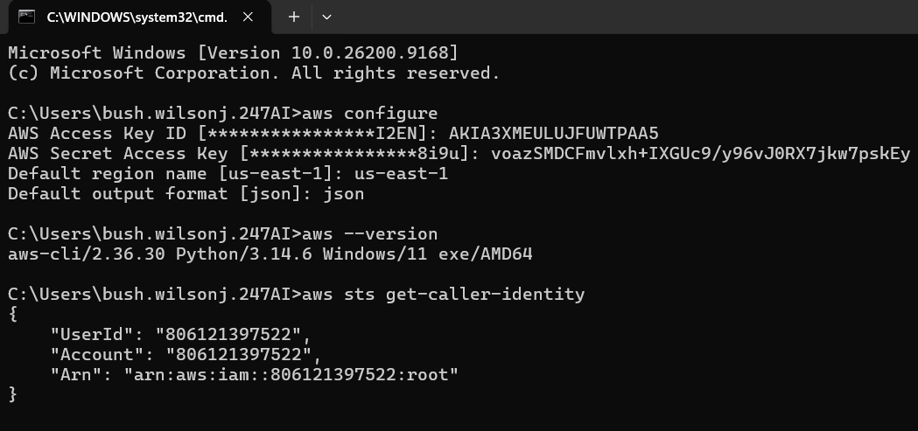

EKS Cluster Created:
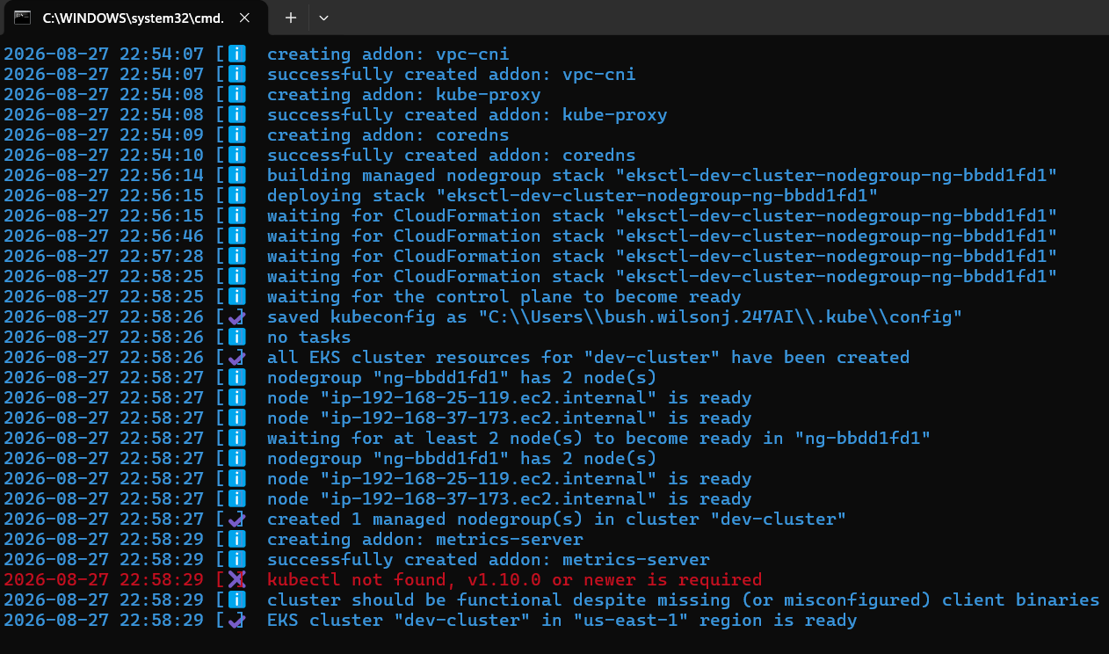

Kubectl:
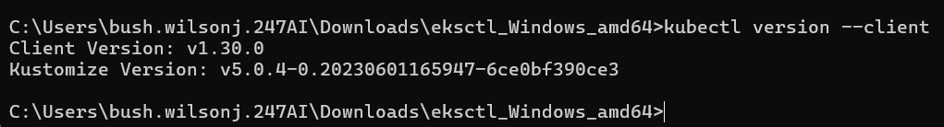

Nginx Pods:
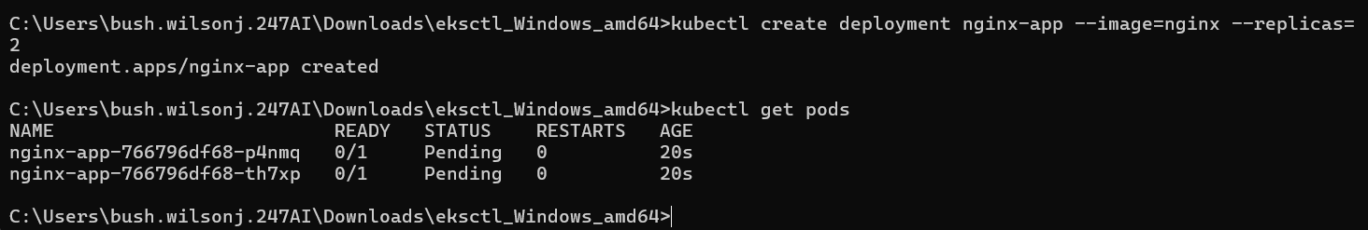

Expose Service Externally:
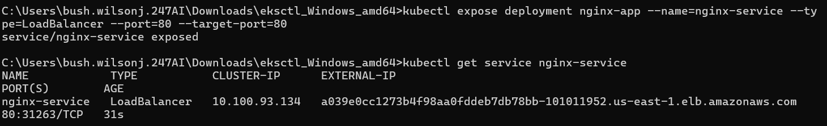

Access via Terminal:
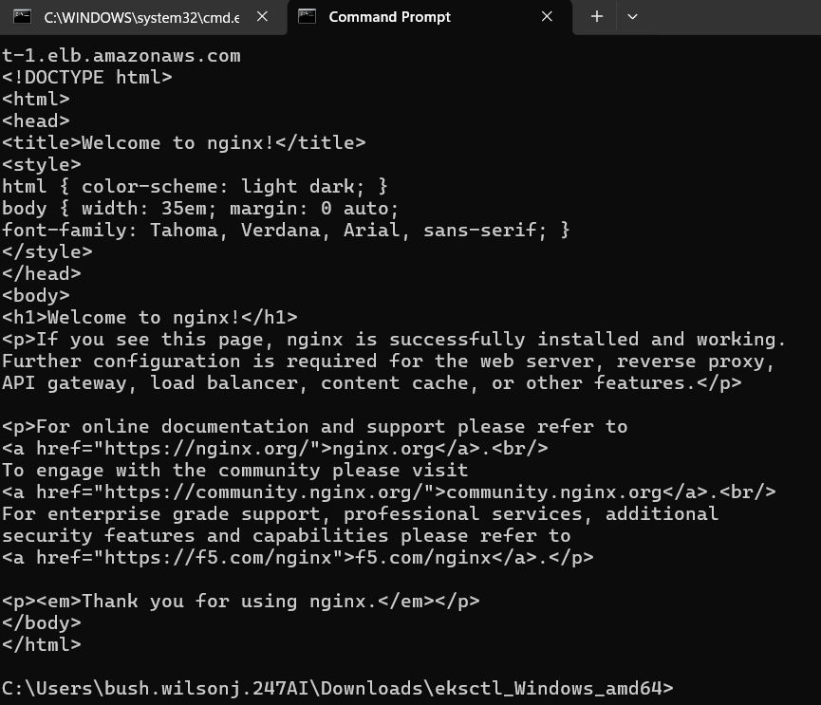
Access via Browser:
